War in Alakai Design Document

RTS

Humans versus humans

3D

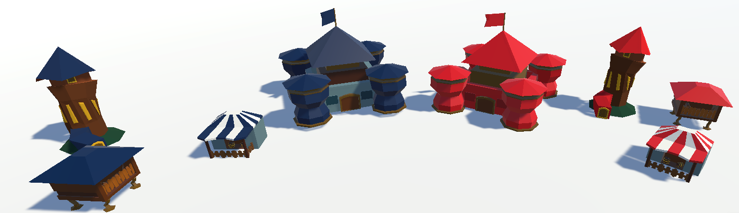

Buildings built in a low poly style.

The buildings have two variations of colors, blue being the player side and red being the enemy side.

The buildings have multiple purposes within the game:

* **Castle**: it is spawned at the beginning and determines the base of the player/AI. Produces gold, and once upgraded it makes the building radius around it bigger so a player/ai can build something at a bigger distance from the base. (generates 5 gold/ second)
* **Lumber mill** - Cost: 350 gold. It generates lumber, and it can spawn Warriors. (generates 10 lumber/second)
* **Mage tower** - Cost: 500 gold and 150 wood. The mage tower is a defensive structure, and it can spawn mages.
* **Workshop** - Cost: 1000 gold and 500 wood. It spawns catapults (strong characters in the game).